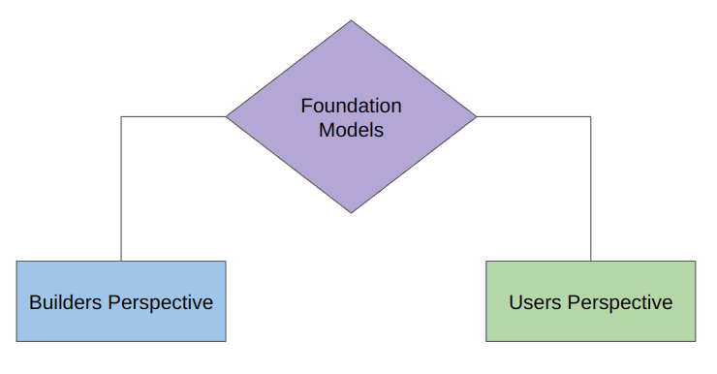

**Builders Perspective:**

1. Transformer Architecture
2. Types of Transformer
   1. Encoder only (BERT)
   2. Decoder only (GPT)
   3. Encoder-Decoder based (T5)
3. Pretraining
   1. Training Objectives
   2. Tokenization Strategies
   3. Training Strategies
   4. Handling Challenges
4. Optimization
   1. Training Optimization
   2. Model Compression
   3. Optimization Inference
5. Finetuning
   1. Task Specific Tuning
   2. Instruction Tuning
   3. Continual Pretraining
   4. RLHF
   5. PEFT
6. Evaluation
7. Deployment

**Users Perspective:**

1. Building Basic LLM apps
   1. Open-source vs close-source LLMs
   2. Using LLM APIs
   3. LangChain
   4. HuggingFace
   5. Ollama
2. Prompt Engineering
3. RAG
4. Fine Tuning
5. Agents
6. LLMOps
7. Miscellaneous

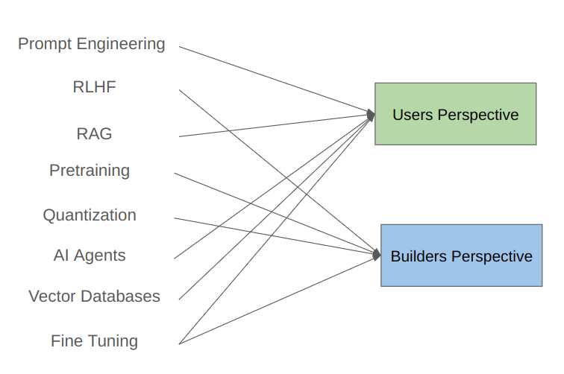

**LangChain**

* LangChain is an open source framework for developing applications powered by LLMs.

**Benefits:**

1. Concepts of Chains
2. Model Agnostic Development
3. Complete Ecosystem
4. Memory and State Handling

**What we can build using LangChain:**

1. Conversational Chatbots
2. AI Knowledge Assistants
3. AI Agents
4. Workflow Automation
5. Summarization/Research Helpers

**LangChain Alternatives:**

1. LlamaIndex
2. Haystack

**Components of LangChain:**

